**Library Management System**

**Data Model and ERD**

**CS 157A - Team #22**

Michael Leonard

Nicholas Papano

Sarah Saber

Entities and their attributes:

* USER : A user is any person that will use the system. There are two types of users, library customers and library employees. All users have the following attributes:
  + Library card number
  + Email
  + Name
  + Password
  + Type
* CUSTOMER: A CUSTOMER is a type of USER. Customers have an account start/expiry date, and can have fines for overdue books.
  + Account start date
  + Account expiry date
  + Fines on account
* LIBRARIAN: A LIBRARIAN is a type USER. Librarians have additional attributes such as a start/hire date and a pay rate.
  + Hire/volunteer start date
  + Pay
* ITEM : An ITEM is any item in the library inventory that can be loaned to customers. All items have the following attributes:
  + Call number
  + Type
  + Genre
  + Status (available, checked out, on hold)
  + Late fee
  + Donated
  + Loan period
  + Purchase Price
* BOOK: A BOOK is a type of ITEM. Books have additional attributes for author and publishing information.
  + Title
  + Author
  + Publishing date
* MOVIE: A MOVIE is a type of ITEM. Movies have additional attributes for the following:
  + Year
  + Director
  + Actors

Relationships and their attributes

* USER borrows ITEM: Users borrow items from the library. This relationship records the information about which users have checked out which items. A currently borrowed item has the following attributes:
  + Borrow date
  + Due date
  + Number of renewals
  + Whether it’s overdue or not
* USER places a hold on ITEM: Users can place a currently borrowed item on hold, so that they can check it out when it returns. This relationship records the ID of the user placing an item on hold, the item being placed on hold, and the date it is due back.
  + Due date for item
* USER adds ITEM to wish list: Users can have a wish list of items to check out in the future. This relationship records pairs of user IDs and item IDs to record the wish list for each user.
* USER history of ITEM: A record of all items checked out by all users. Records the user ID and item ID for each item checked out, as well as the following information:
  + Borrow date
  + Return date
  + Whether it was returned late or not
* LIBRARIAN generates report on ITEM: Librarians can run a report to collect information about item status for all library inventory. These reports include the following information:
  + Num of items on hold
  + Num of overdue items

ISA:

* BOOK ISA ITEM
* MOVIE ISA ITEM
* CUSTOMER ISA USER
* LIBRARIAN ISA USER

**ERD**

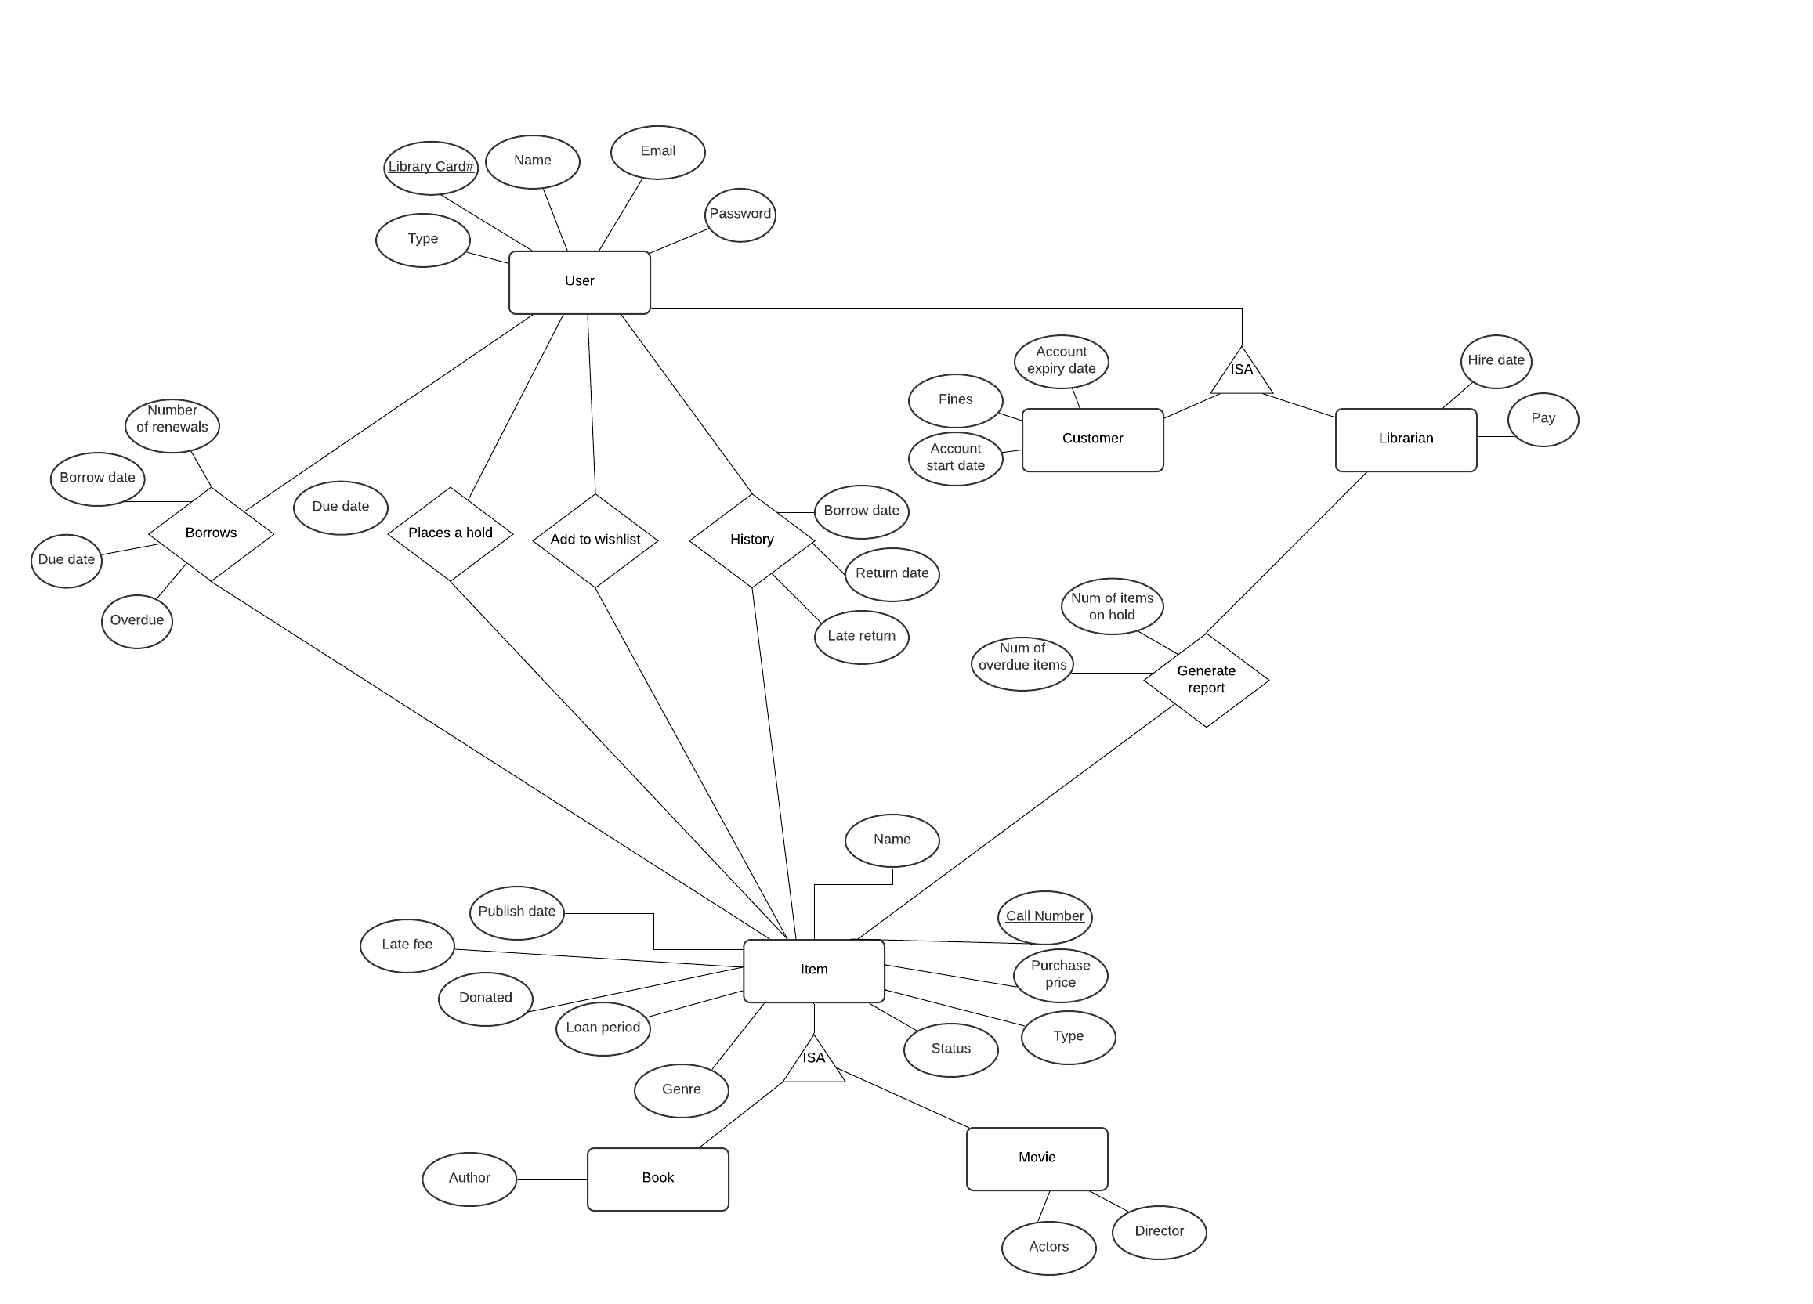

Tables:

User:

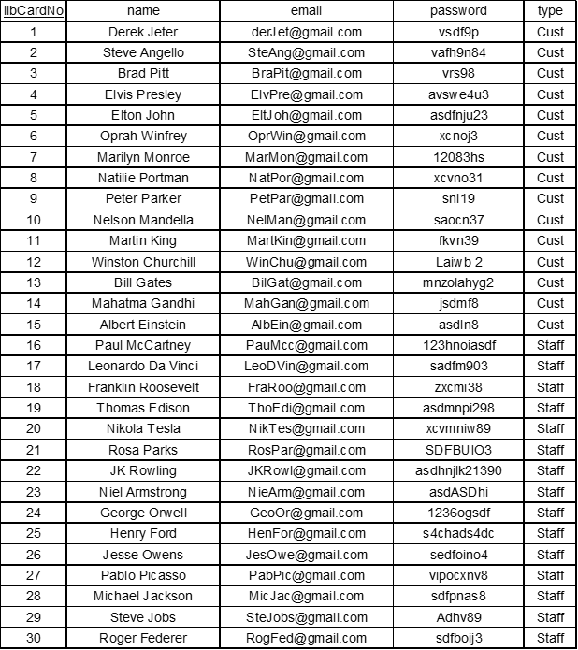

Customer:

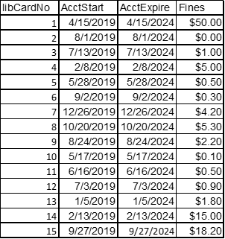

Librarian:

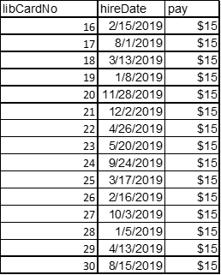

Item:

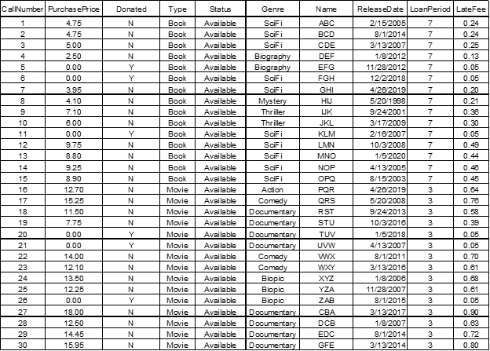

Book

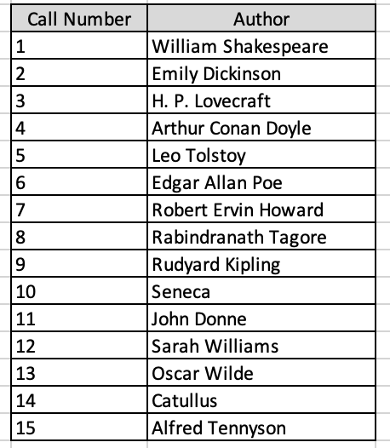

Movie

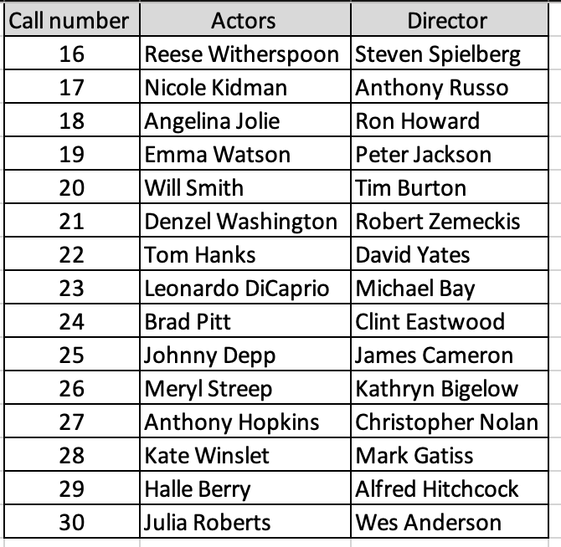

Borrow:

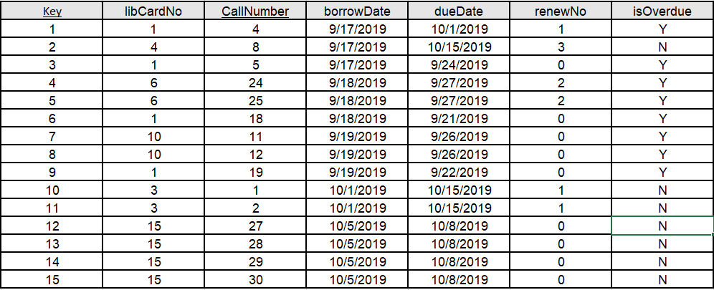

Item History

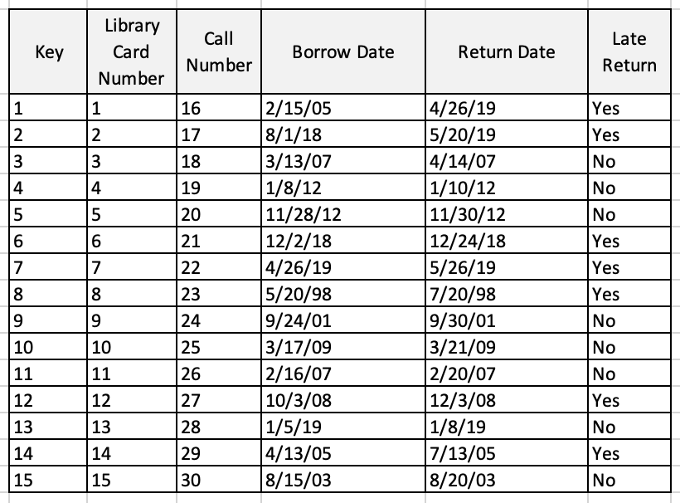

Report Info

|  |  |  |  |
| --- | --- | --- | --- |
| itemsOnHoldNum | overdueItemNum | Library Card # | Call Number |
| 1412 | 987234 | 1 | 1 |
| 1234 | 234 | 2 | 2 |
| 2 | 7834 | 3 | 3 |
| 123 | 34789 | 4 | 4 |
| 145 | 534 | 5 | 5 |
| 789 | 897 | 6 | 6 |
| 75 | 36 | 7 | 7 |
| 21334 | 862345 | 8 | 8 |
| 10234 | 67345 | 9 | 9 |
| 9563 | 443 | 10 | 10 |
| 12047 | 12 | 11 | 11 |
| 2478 | 437 | 12 | 12 |
| 98234 | 23 | 13 | 13 |
| 93 | 7 | 14 | 14 |
| 49 | 21 | 15 | 15 |

Hold

|  |
| --- |
| Due date |
| 4/12/2019 |
| 8/16/2019 |
| 7/3/2019 |
| 2/1/2019 |
| 5/18/2019 |
| 9/22/2019 |
| 12/16/2019 |
| 10/10/2019 |
| 8/4/2019 |
| 5/7/2019 |
| 6/6/2019 |
| 7/23/2019 |
| 1/15/2019 |
| 2/3/2019 |
| 9/7/2019 |